About properties

While you might think about your website or mobile app as a distinct, real-world piece of property, like a storefront, Analytics understands a property only as a resource associated with your tracking code. When you track a resource using Analytics, you include a property ID in the tracking code that you put on your web pages or in your app source code. Performance data, like number of users or screen views, for resources tagged with the same ID is collected into the corresponding property.

For example, if you associate one property ID with two websites, data for both websites appears in the same property in your Analytics account. You can then use [views](https://support.google.com/analytics/answer/2649553) and [filters](https://support.google.com/analytics/answer/1033162) to organize the data. You can segregate the data even further at the report level with tools like [Segments](https://support.google.com/analytics/answer/1033017).

Consider your long-term reporting goals and how they might affect your account structure. Create an implementation plan before you set up new properties. In some cases, you may want to have multiple resources all send data to the same property. In other cases, you may want each resource to send data to a separate property. In either case, you can use views and filters to create specific perspectives of your data.

**Start analyzing your site's traffic in 3 steps**

* **1** Sign up for Google Analytics

All we need is some basic info about what site you'd like to monitor.

* **2** Add tracking code

You'll get a tracking code to paste onto your pages so Google knows when your site is visited.

* **3** Learn about your audience

In a few hours you'll be able to start seeing data about your site.

## Getting Tracking ID

<https://analytics.google.com/analytics/web/provision/?authuser=0#/provision/create>

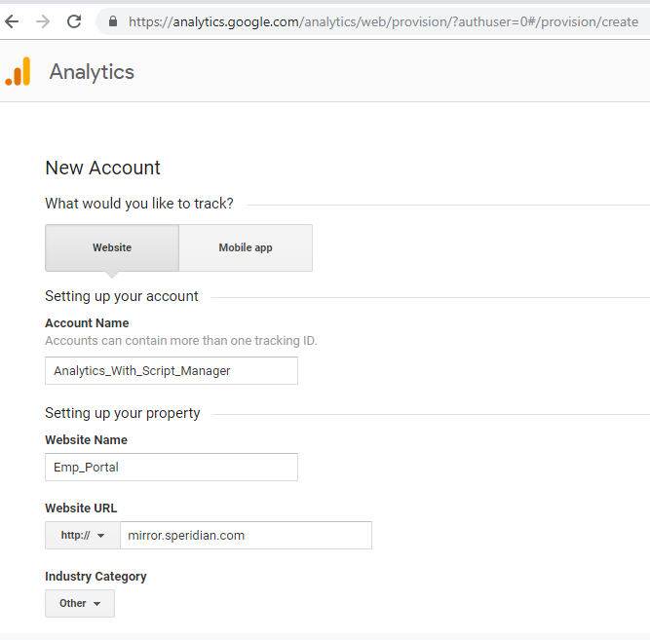

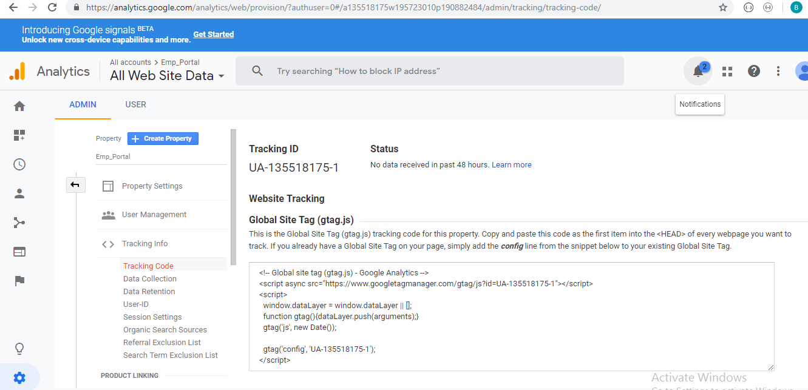

## **Find an API**

<https://developers.google.com/analytics/devguides/integrate/>

# Add a project to Google cloud platform

# <https://console.cloud.google.com>

# 

# 

# 

# 

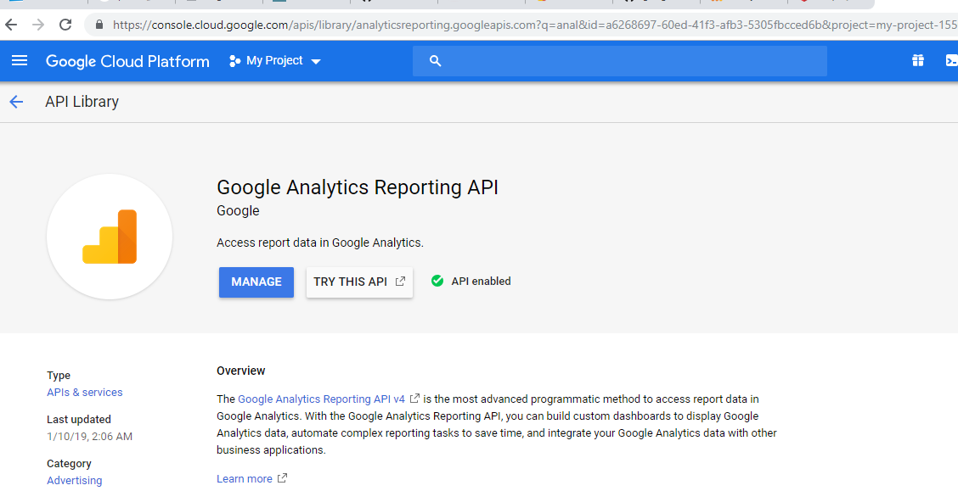

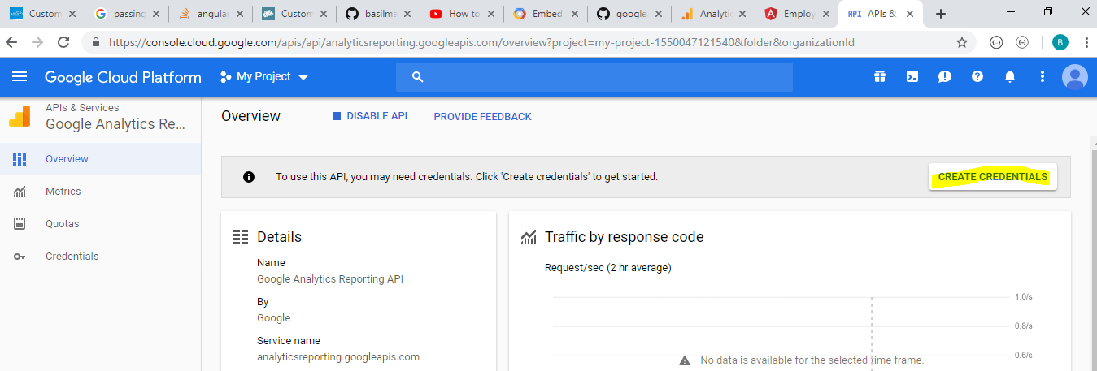

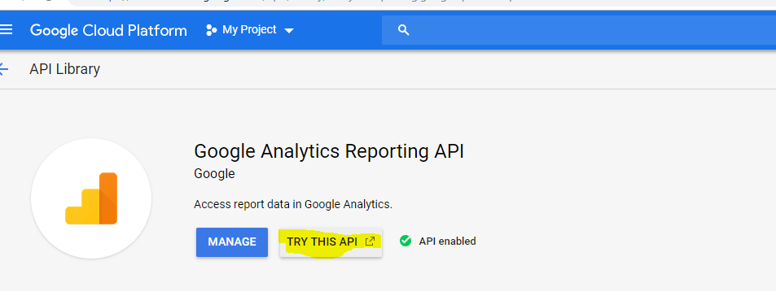

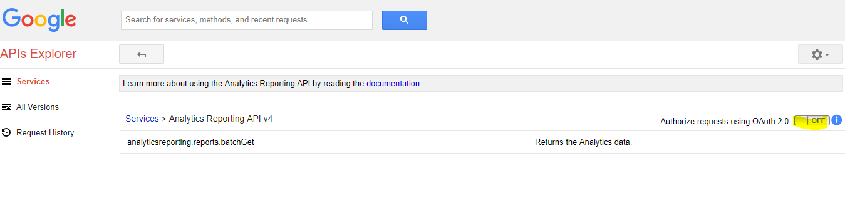

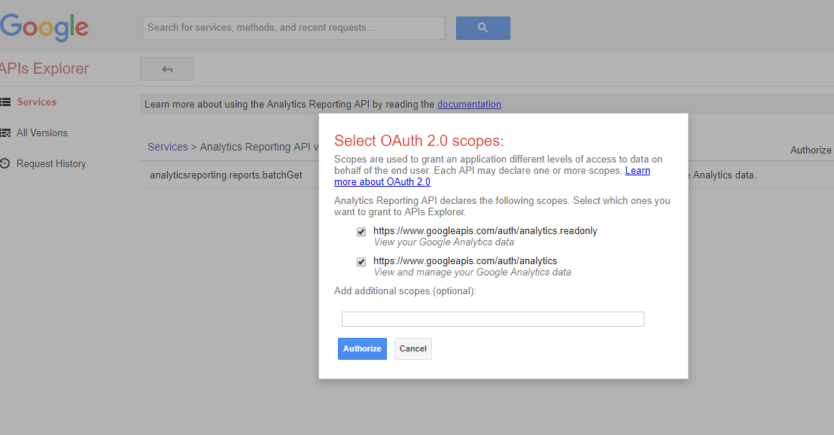

Click authorize

Select Gmail account

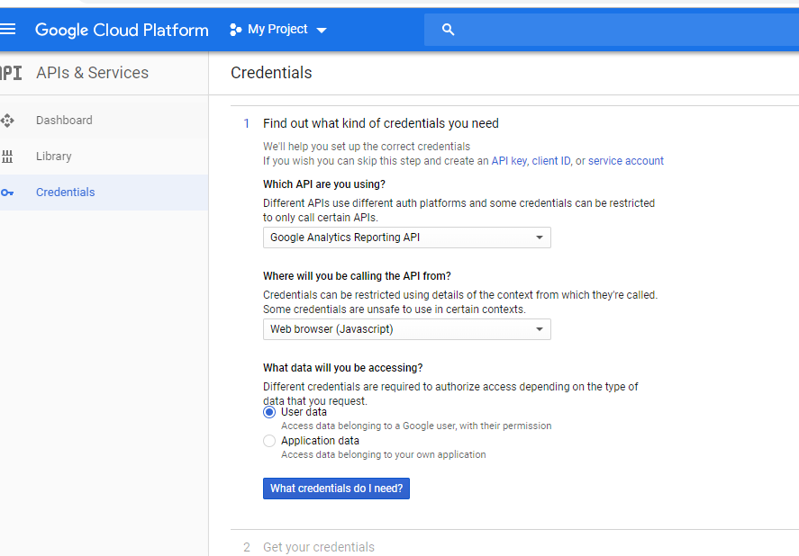

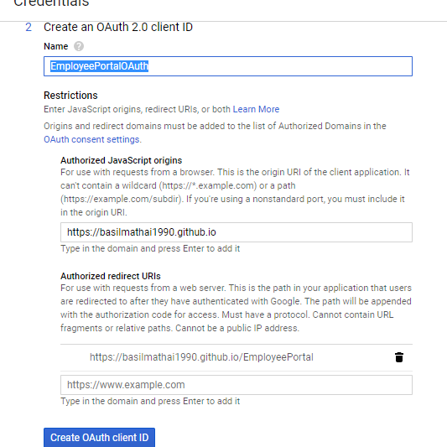

**Oath** ->Web client 1 **Customer Name**->Employee_Portal

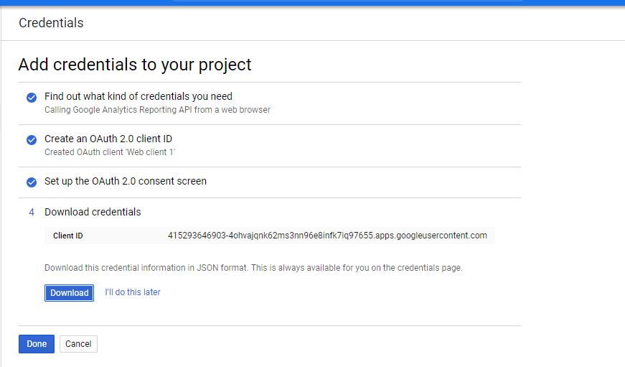

**Client ID**: 415293646903-4ohvajqnk62ms3nn96e8infk7iq97655.apps.googleusercontent.com

<https://ga-dev-tools.appspot.com/account-explorer/>

<https://ga-dev-tools.appspot.com/query-explorer/>

<https://console.cloud.google.com/>